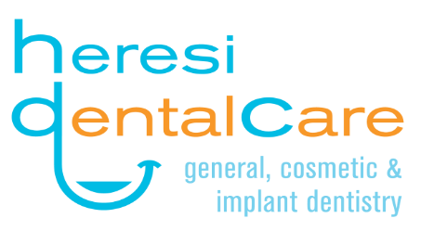

2019 Novel Corona Virus Disease (COVID-19)
Screening Questionnaire

- Have you recently travel to China, Iran, South Korea, Japan or any other geographic location where the Novel Coronavirus(COVID-19) has been transmitted, or have you had close contact with a patient who has or is suspected of having the Novel Coronavirus (COVID-19)?
Yes___
No___

- Do you currently have, or have you experienced any of the following symptoms within the last fourteen (14) days - fever, cough, shortness of breath or difficulty breathing?

Yes___
No___

- In the last 14 days, have been in close contact with anyone who has experienced any of the following symptoms- fever, cough, shortness of breath or difficulty breathing?

Yes___
No___

Person completing the form (if other than the patient) ______________

Patient name (in print) _________________________________________

Signature of patient _______________________________________

Date: _______________

